Push the image to the IBM Cloud Registry

1. From your account dashboard, go to **IBM Cloud Kubernetes Service**.
2. From the left navigation menu, select **Private Repositories**.

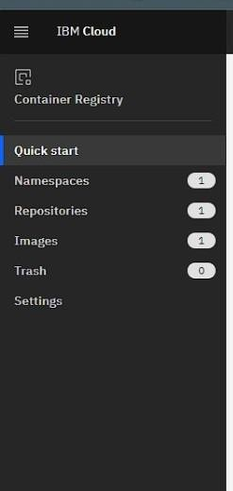

1. Install the Container Registry plug-in.

|  |  |
| --- | --- |
| 4. | ibmcloud plugin install container-registry -r "IBM Cloud" |

5. Log in to your IBM Cloud account.

6. ibmcloud login -a <cloud_foundary_end_point_for_the_region>

1. Name and create your namespace. Use this namespace for the rest of the Quick Start.
2. ibmcloud cr namespace-add <namespace>
3. Log your local Docker daemon into the IBM Cloud Container Registry.

ibmcloud cr login

1. Choose a repository and tag by which you can identify the image. 12.

docker tag <image_name> <region_url>/<namespace>/<image_name>:<tag>

13. Push the image. 14.

docker push <region_url>/<namespace>/<image_name>:<tag>

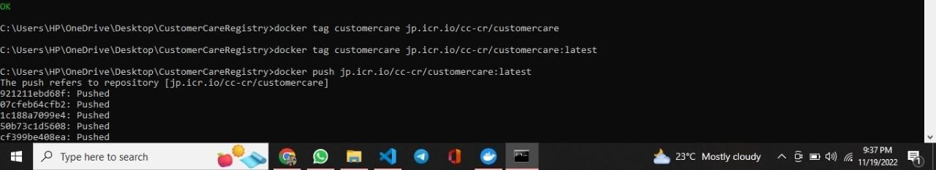

1. Verify that your image is in your private registry.

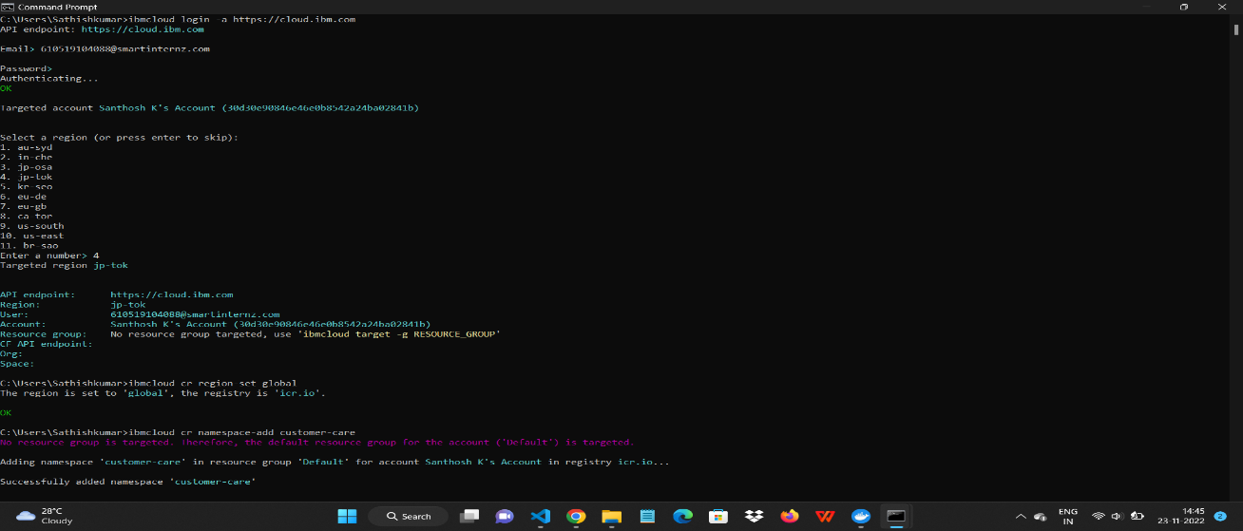

1. ibmcloud cr image-list